SYNOPSIS

ON

“College Solution Management System”

Submitted in

Partial Fulfillment of requirements for the Award of Degree

*of*

Bachelor of Technology

*In*

Computer Science and Engineering

(Mention Specialization, if any otherwise remove this line)

By

**(Project Id: )**

# Nikhil Kumar Singh (2101641520096)

# Vaibhav Saxena (2101641520148)

# Shreyash Yadav (2101641520136)

**Shivang Maurya (2101641520132)**

# Purthi Mishra (2101641520110)

Under the supervision of

**Supervisor Name**

**(Designation)**



**Pranveer Singh Institute of Technology**.

 Kanpur - Agra - Delhi National Highway - 19

Bhauti -Kanpur - 209305.

(Affiliated to Dr. A.P.J. Abdul Kalam Technical University)

1. Introduction

A lot of students suffer from lack of concentration when they get into the new environment of engineering college. After that, they don't know what to do in their academic sessions. This prevents them from scoring well on their exam sessions.

It is likely that initially they do not know what they need to learn, how they need to learn, and when they need to learn .... causing poor academic results by which they are not able to find good employment opportunities by which they are forced to work hard to find a good position.

##introduction at least one page ka

2. Project Objective

* In order to facilitate the study of the students, a website will be developed that provides them with notes, syllabus, and road maps, as well as solutions to the problems they encounter throughout their academic career.
* Furthermore, the website contains information about different types of programming languages and different types of coding platforms

* We are planning to add CHATBOT which will make student to search particular notes easily.
* This will provide you well organized notes and solution that will help in solving the problem of the students entering in fresh engineering environment.
* Unlike a human customer service agent, a chatbot is available 24/7, addressing queries from multiple customers at the same time. This ensures the customers that there is someone to listen to them, address their queries, or take their issues forward.
* Chatbots are deployed on messaging interfaces which gives a casual messaging experience to the customers as if they are talking to one of their friends.

This should give a clear picture of the project. Objectives should

be clearly specified. What the project ends up to and in what way

this is going to help the end user has to be mentioned.

1. Feasibility Study:

* The benefits of using this website are numerous. To give you a hint, there are some of them:
* Students who study online have flexible schedule and they can learn using this website when they have time.
* It leads to increasing their satisfaction from learning through this and helps in reducing their stress.
* Facilitation of a comprehensive understanding of the subject-matter through interactive learning techniques such as videos, notes provided, audios, etc.
* A lot of online learning platforms offer premium subscription whereas freshers get access to all courses and study material related to their courses at free of cost.
* High quality learning, owing to high quality-content.

4. Methodology/ Planning of work

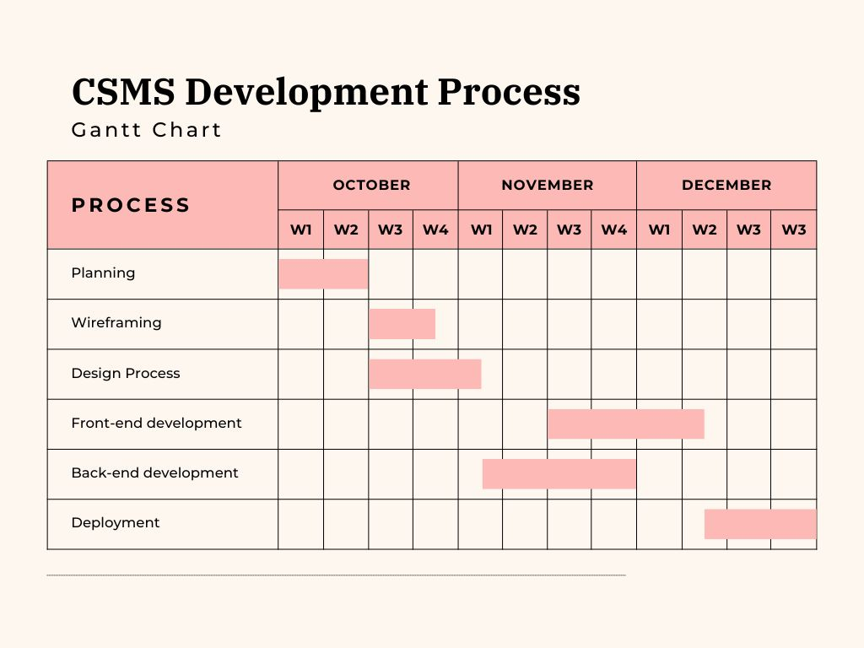

5. Tools/Technology Used:

5.1 Hardware Requirements

* Hardware required for the development of the project.
* Intel core i3 10th gen
* RAM-:4 GB
* Hard disks -: 512 GB

5.2 Software Requirements

* Software required for the development of the project.
* Visual studio 1.72
* Github
* Git
* Atoms

6. References:

1. W3 school
2. Udemy
3. Javapoint
4. Youtube

.

**Guidelines:**

1) Heading Font Size: 14

2) Content Font Size: 12

3) Font Name: Times New Roman

4) Line Spacing: 1.5”

5) Alignment: Left & Right both Justified

6) Margin: Normal (Top=2.54 cm, Bottom=2.54 cm, Left=2.54 cm, Right=2.54 cm)

7) Page No: At Bottom Right Side

Note: Consider this format for your reference.